Welcome!
Date
Name
Spouse
Address
City
State Zip _________
Email

Please Contact By
❑ Card  Phone  Visit

Telephone Best Time to Call
Home ______________
Work ______________

Guest: First Time Second Time
Are you a church member: yes no
Church
City, State

Circle Appropriate Age/Grade Group(s)
Preschool: Ages: B-1 2-3 4-5
Children: Grades: K 1 2 3 4 5 6
Youth: Grades: 7 8 9 10 11 12
Adults: Ages:18-29 30s 40s 50s 60s+

How did you learn about our church?
Newspaper Friend Yellow Pages Mail
Other

I am a guest of:

New in the Community? Yes No
Names & ages of children at home

Weekly Service & Activity Schedule

July 20, 2014
9:45 a.m. Sunday School
11:00 a.m. Morning Worship Service

Week of July 21
Wednesday, 6:45 p.m. Adult Prayer & Bible Study
Thursday, 10:00 a.m. Senior Adult Fellowship
Monday – Friday Journey Youth Camp
Time to get ready for VBS!!!
Sign up sheet on the bulletin board
by SS rooms.

Contact Patti Radford 512-968-7821
Patti.radford@yahoo.com August 3rd- 7th



Youth will not meet on 7/16 & 7/23. Youth will resume on Wednesday 7/30 @ 7:00pm

Youth Camp
July 21-24

Upcoming Events
July
27………………………….....Recognition of Church Leaders
27…………………………...…..Birthdays and Anniversaries
August
3…………………………………….…………….Kids In Action
3-7…………………………………….…Vacation Bible School
16………………………………………………….Church Picnic

Kids in Action 1st Sunday of each month

Birthday & Anniversary Recognitions will occur on the final Sunday of each month.

Knobbs Springs Baptist Church

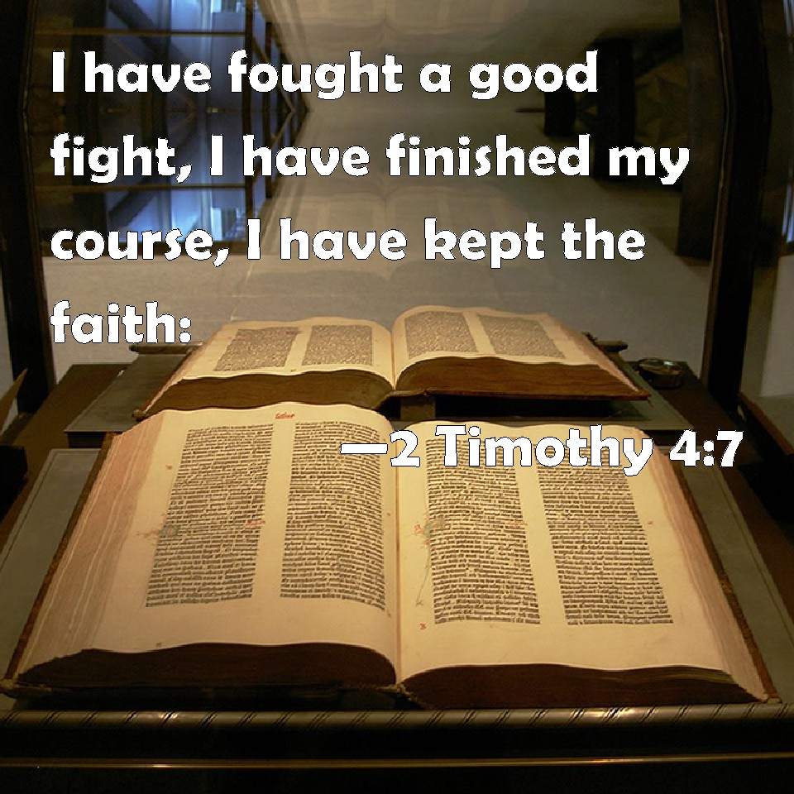
Welcome Bro. David Marchbanks

July 20, 2014

Church Information:

KnobbsSpringsBC.com KnobbsSpringsBaptist@gmail.com
1662 CR 305, McDade, Texas 78650 512-273-2743
Dena Ruthven, Office Manager 512-273-2743

